DMV Assignment 5

Syed Muhammad Hassan Raza – 26645

Question 1: Find the names of employees who earn more than the average salary of their department.

SELECT FIRST_NAME, LAST_NAME

FROM OEHR_EMPLOYEES A

WHERE SALARY > (SELECT AVG(SALARY)

FROM OEHR_EMPLOYEES

WHERE DEPARTMENT_ID = A.DEPARTMENT_ID)

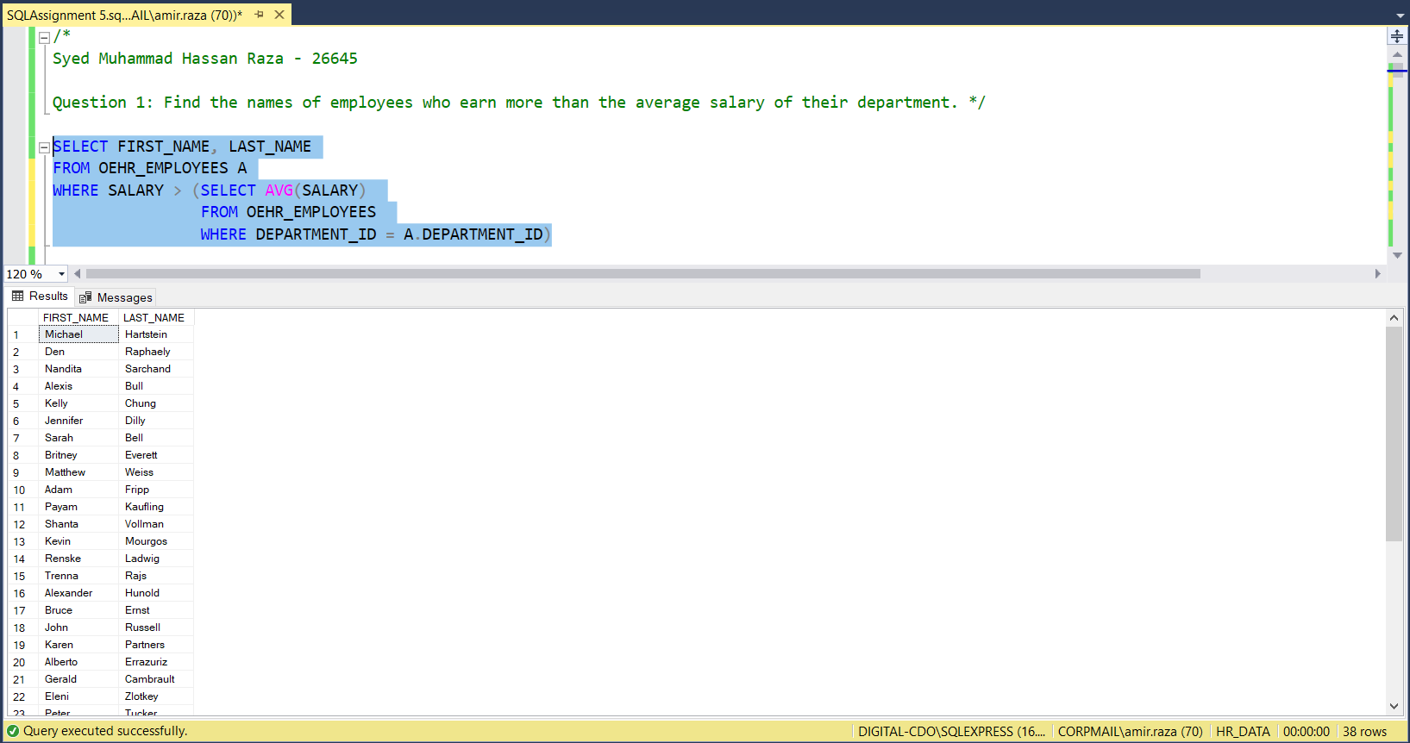

Question 2: Write a SQL query to find details of those employees where the salary falls within the range of the smallest salary and 2500. Sort the results by highest salary to lowest salary. Put the results in a table and show results.

SELECT *

INTO #SALARY_RANGE

FROM OEHR_EMPLOYEES

WHERE SALARY BETWEEN (SELECT MIN(SALARY) FROM OEHR_EMPLOYEES) AND 2500

ORDER BY SALARY DESC

SELECT * FROM #SALARY_RANGE

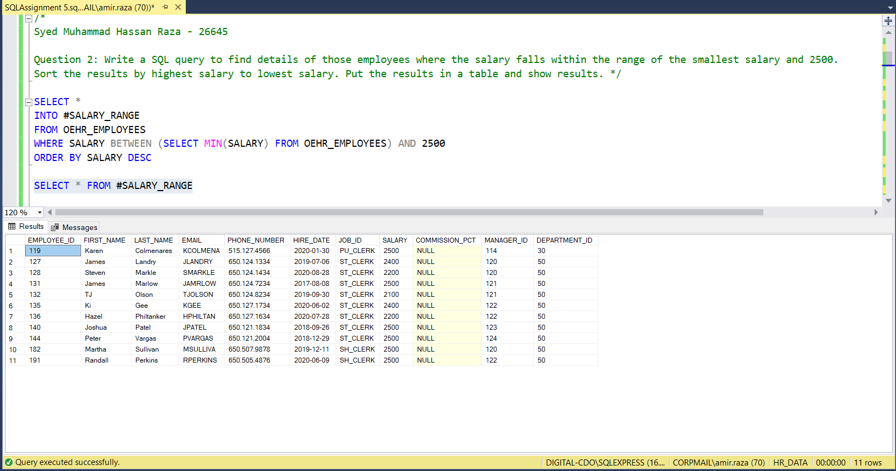

Question 3: List all employees who work in the same department as a manager.

SELECT FIRST_NAME, LAST_NAME

FROM OEHR_EMPLOYEES

WHERE DEPARTMENT_ID IN ( SELECT DEPARTMENT_ID

FROM OEHR_EMPLOYEES

WHERE JOB_ID LIKE '%MAN%')

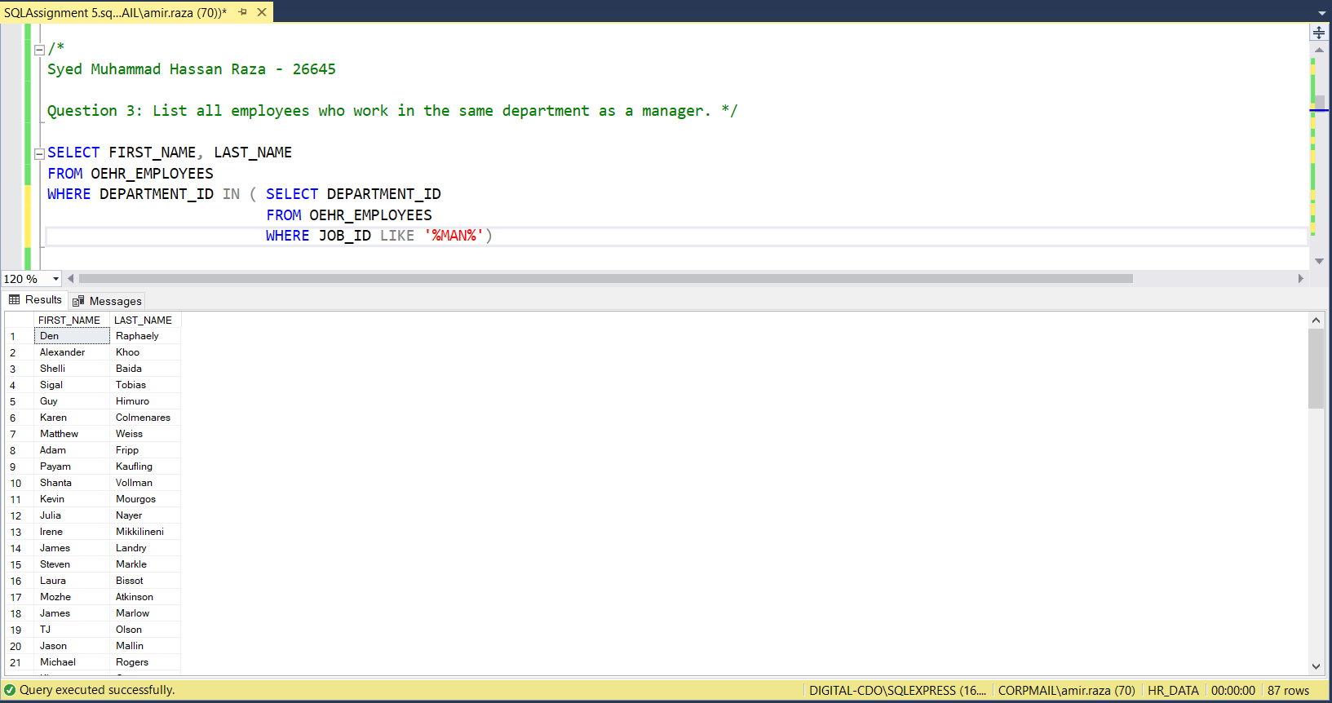

Question 4: Using Subqueries, Find the departments with no employees.

SELECT DEPARTMENT_NAME, DEPARTMENT_ID

FROM OEHR_DEPARTMENTS A

WHERE DEPARTMENT_ID NOT IN (SELECT DISTINCT DEPARTMENT_ID

FROM OEHR_EMPLOYEES

WHERE DEPARTMENT_ID=A.DEPARTMENT_ID )

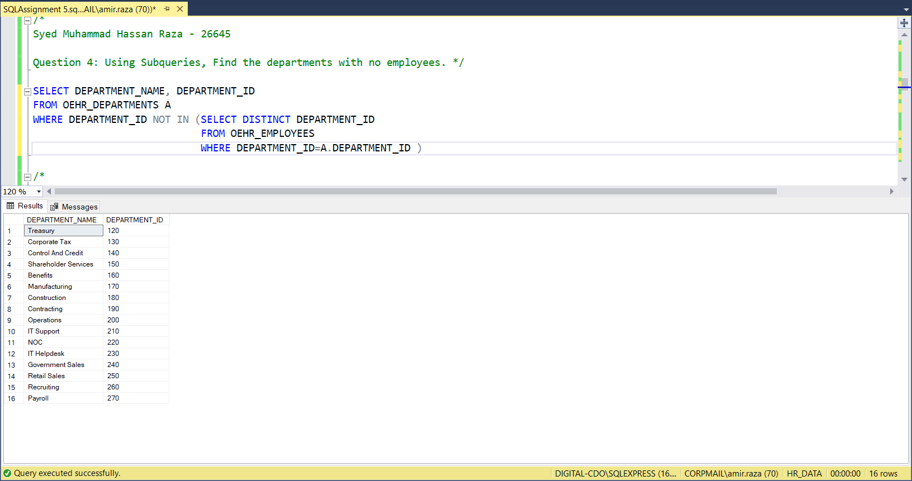

Question 5: Find employees who were hired after the company's mean hiring date.

SELECT *

FROM OEHR_EMPLOYEES

WHERE HIRE_DATE > (SELECT DATEADD(DAY, AVG(DATEDIFF(DAY, '2000-01-01', HIRE_DATE)), '2000-01-01') 'MEAN HIRING DATE'

FROM OEHR_EMPLOYEES )

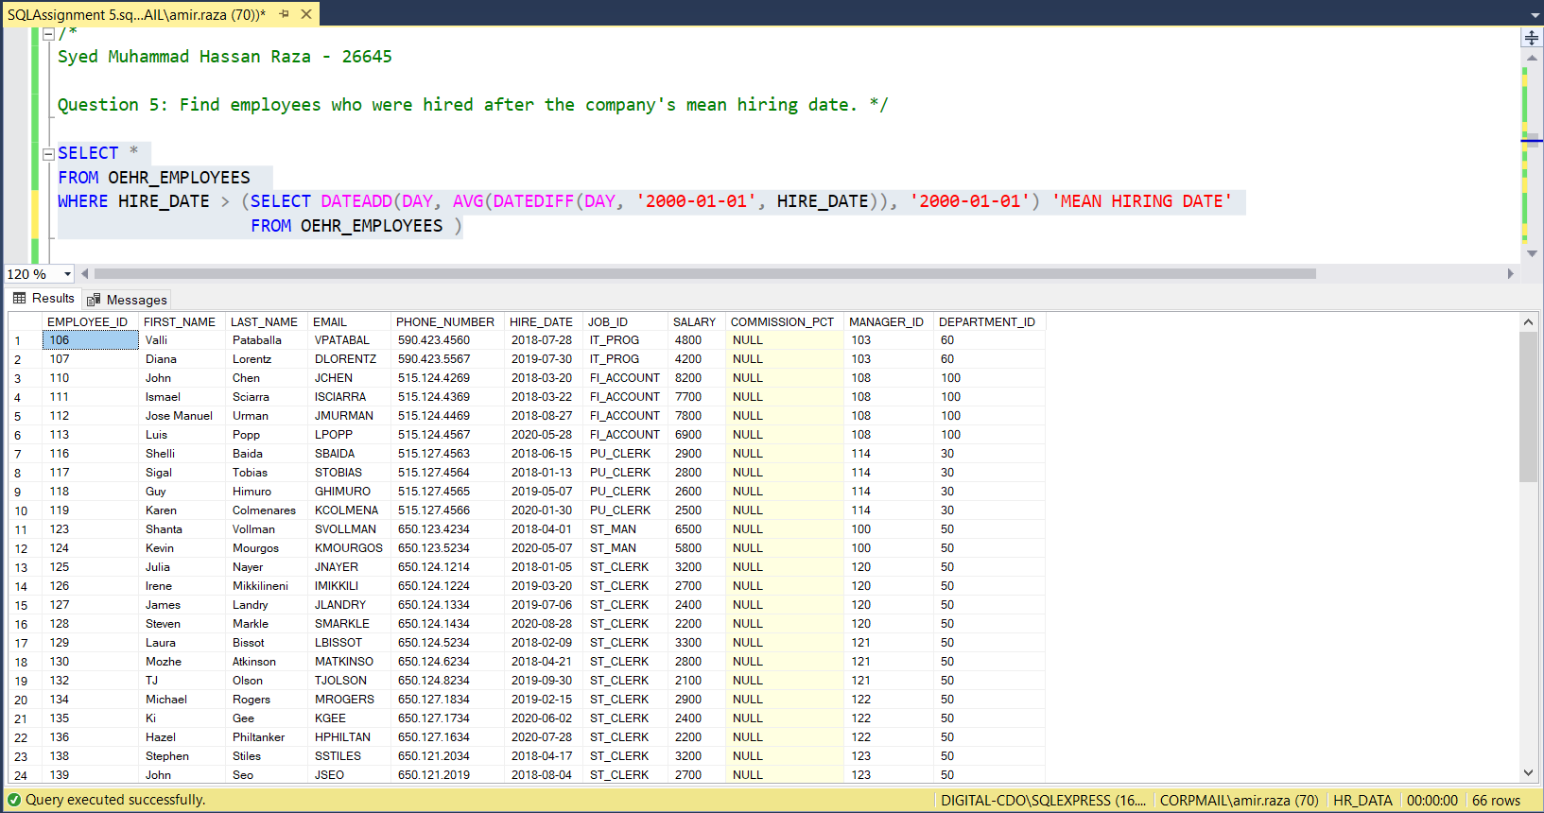

Question 6: List the names of all managers who have at least 5 employees in their department.

SELECT FIRST_NAME, LAST_NAME

FROM (SELECT * FROM OEHR_EMPLOYEES WHERE JOB_ID LIKE '%MAN%') AS MANAGERS

WHERE DEPARTMENT_ID IN ( SELECT DEPARTMENT_ID

FROM OEHR_EMPLOYEES

WHERE JOB_ID <> '%MAN%'

GROUP BY DEPARTMENT_ID

HAVING COUNT(*) >= 5)

Question 7: Find the departments where the average salary is greater than the company's overall average salary.

SELECT A.DEPARTMENT_NAME, A.DEPARTMENT_ID

FROM OEHR_DEPARTMENTS A

INNER JOIN OEHR_EMPLOYEES B

ON A.DEPARTMENT_ID=B.DEPARTMENT_ID

GROUP BY DEPARTMENT_NAME, A.DEPARTMENT_ID

HAVING AVG(SALARY) > (SELECT AVG(SALARY) FROM OEHR_EMPLOYEES)

Question 8: List the employees who have a job title that is not present in the job history table.

SELECT EMPLOYEE_ID, FIRST_NAME, LAST_NAME

FROM OEHR_EMPLOYEES A

WHERE NOT EXISTS (SELECT *

FROM OEHR_JOB_HISTORY B

WHERE A.JOB_ID=B.JOB_ID)

Question 9: Find the names of employees who have been in the company longer than the average tenure of employees in their department.

SELECT FIRST_NAME, LAST_NAME, DATEDIFF (YEAR, HIRE_DATE, GETDATE()) 'Years In Company'

FROM OEHR_EMPLOYEES A

WHERE DATEDIFF (DAY, HIRE_DATE, GETDATE()) > ( SELECT AVG(DATEDIFF(DAY, HIRE_DATE, GETDATE()))

FROM OEHR_EMPLOYEES

WHERE DEPARTMENT_ID=A.DEPARTMENT_ID)

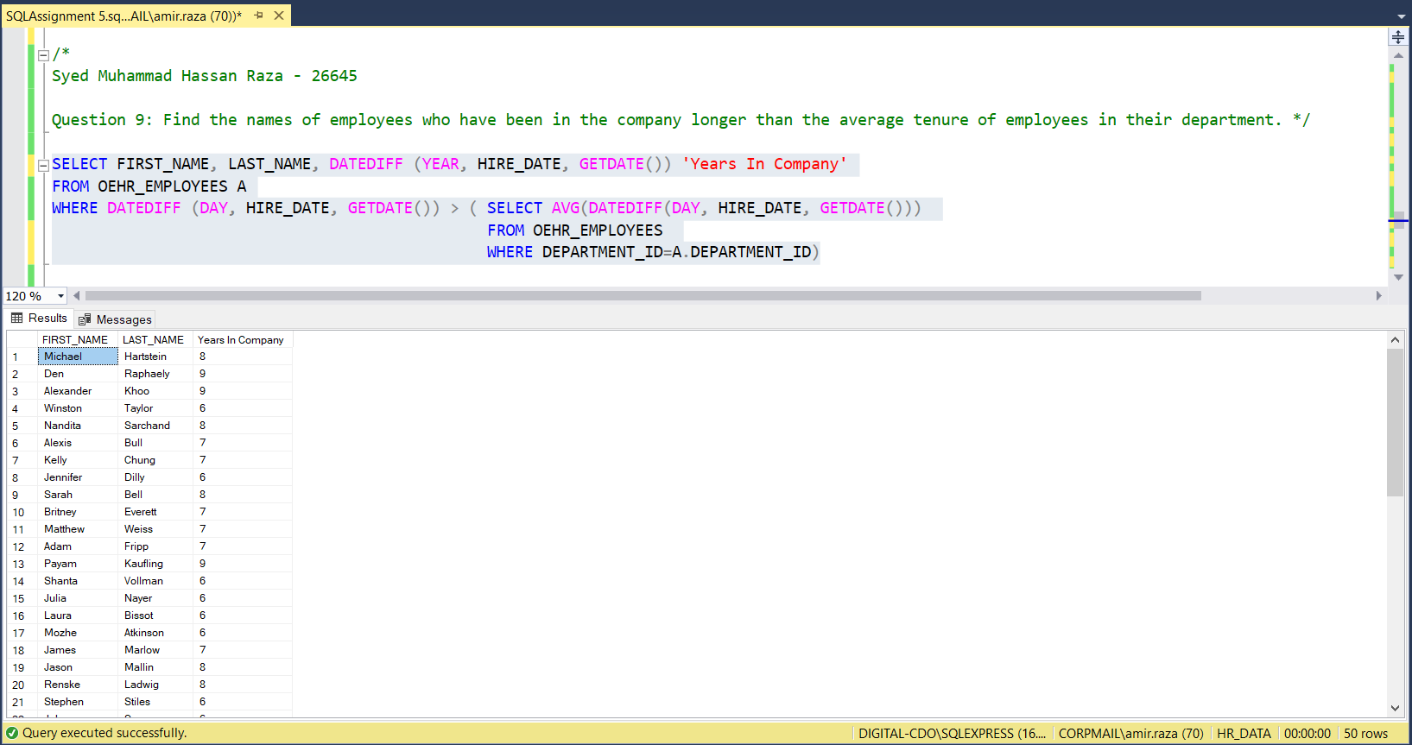

Question 10: Find the employee with the 3rd highest salary.

SELECT TOP 1 EMPLOYEE_ID, FIRST_NAME, LAST_NAME, SALARY

FROM dbo.OEHR_EMPLOYEES

WHERE EMPLOYEE_ID NOT IN (

SELECT TOP 2 EMPLOYEE_ID

FROM dbo.OEHR_EMPLOYEES

ORDER BY SALARY DESC)

GROUP BY EMPLOYEE_ID, FIRST_NAME, LAST_NAME, SALARY

ORDER BY SALARY DESC

